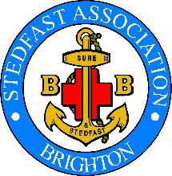
Membership Form for 2024
May we remind you that subscriptions are due, the present recommended subscription for members and associate members is £10-00 per year (more/less if you wish).
Subscription/Contribution enclosed £
Cheques payable to “ Stedfast Association “.. please
Or pay directly to the following bank account:-

Lloyds Bank plc
Account name-The Stedfast Association Brighton
Sort code-30-90-89
Account number-56240860
Company...........................................................
Name..................................................................
Address...............................................................
....................................................................
.................................................................... Tel Number...................................
Post Code......................................

E mail |  |  | Post
Confirm e-mail .........................................................................
Newsletter via email OR Hard copy by post...........Please indicate in one box
Old Boy........... Officer.... ....... Helper ........... Friend /Supporter........... Band Member...........
Please return this completed form together with your subscription to:-
The Secretary Alan Caperon
72 Poulter’s Lane
Worthing
West Sussex BN14 7SZ
Should you no longer wish to remain on our mailing list, would you also please inform the Secretary by email to alan.caperon@hotmail.co.uk

